**Form: Blog Recipe Competition**

**1. Recipe Name**

Answer : Classic tomato salsa with basil

**2. Sub-title** (One-line text that will appear under recipe title)

Answer : WITH HOMEMADE PASTA

**3. Description about recipe** (recipe details, description, purpose, history etc.)

Answer : Place potatoes in a medium saucepan and add cold water to cover by 1″. Bring to a boil, season with salt, and cook until fork-tender, 15–20 minutes. Transfer potatoes to a plate with a slotted spoon.

Return water to a boil and cook haricots verts in same saucepan until crisp-tender, about 2 minutes. Using a slotted spoon, transfer to a bowl of ice water. Chill until cold, about 3 minutes. Transfer to paper towels and pat dry.

Return water in pot to a boil and cook eggs 8 minutes. Transfer eggs to bowl of ice water and chill until cold, about 5 minutes. Peel; set aside.

Meanwhile, heat 2 tablespoons oil in a small saucepan over medium-high. Add capers and cook, swirling pan occasionally, until capers burst and are crisp, about 5 minutes. Transfer capers with a slotted spoon to paper towels to drain. Let oil cool; set aside.

**4. Recipe cuisine** (comma separated if multiple)

Answer : Italian

**5. Recipe brief description** (max. 25 words)

Answer : An old-school dish that everyone loves, this gluten-free lasagne recipe and members

**6. Serves how many people**

Answer : 4

**7. Preparation Time** (in minutes)

Answer : 30

**8. Cooking Time** (in minutes)

Answer : 0

**9. Ingredients Used** (all the ingredients must be listed)

Answer :

The following ingredients are required for this recipe:

|  |  |  |  |  |
| --- | --- | --- | --- | --- |
|  | **Ingredient Name** | **Amount** | **Units** | **Note** |
| 1. | Skim Milk | 250 | ml | Cold milk |
| 2. | Skin-on salmon | 8 | oz |  |
| 3. | Small purple potatoes | 6 | oz |  |
| 4. |  |  |  |  |
| 5. |  |  |  |  |
| 6. |  |  |  |  |
| 7. |  |  |  |  |
| 8. |  |  |  |  |
| 9. |  |  |  |  |
| 10. |  |  |  |  |
| 11. |  |  |  |  |
| 12. |  |  |  |  |
| 13. |  |  |  |  |
| 14. |  |  |  |  |
| 15. |  |  |  |  |
| 16. |  |  |  |  |
| 17. |  |  |  |  |
| 18. |  |  |  |  |
| 19. |  |  |  |  |
| 20. |  |  |  |  |

**10. Appliances & Utensils Used** (all the appliances/utensils must be listed)

|  |  |
| --- | --- |
|  | **Appliance/Utensils Name** |
| 1. | Tablespoons |
| 2. | Saucepan |
| 3. | Swirling Pan |
| 4. | Paper Towels |
| 5. | Brush |
| 6. |  |
| 7. |  |
| 8. |  |
| 9. |  |
| 10. |  |
| 11. |  |
| 12. |  |
| 13. |  |
| 14. |  |
| 15. |  |
| 16. |  |
| 17. |  |
| 18. |  |
| 19. |  |
| 20. |  |

**11. Recipe Steps** (with square shaped images of each step, if possible)

[Note: For image (Copy your stepwise image and paste on appropriate step by step.)]

Answer :

We would follow the below steps for our recipe:

1. Heat 2 tablespoons oil in a small saucepan over medium-high. Add capers and cook, swirling pan occasionally, until capers burst and are crisp, about 5 minutes. Transfer capers with a slotted spoon to paper towels to drain. Let oil cool.

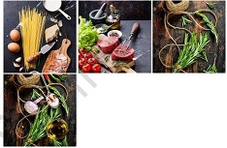

1. Brush the corn with a little of the melted butter and season with salt and pepper. Place on a barbeque or in a preheated griddle pan and cook, turning the cobs, until lightly toasted.

**12. Featured image** (One or more high resolution images of final prepared recipe)

Answer :

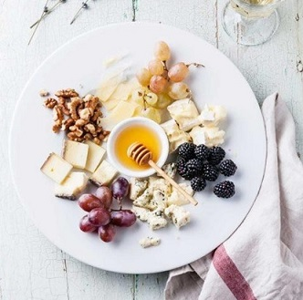

[**For Submission of this file Click Here**](https://contest.blissbite.in/)